**PHASE 5**

**LESSON 4**

**PRACTICE ASSISTED 6**

**SETTING UP A JENKINS PIPELINE**

**Setup Environment:**

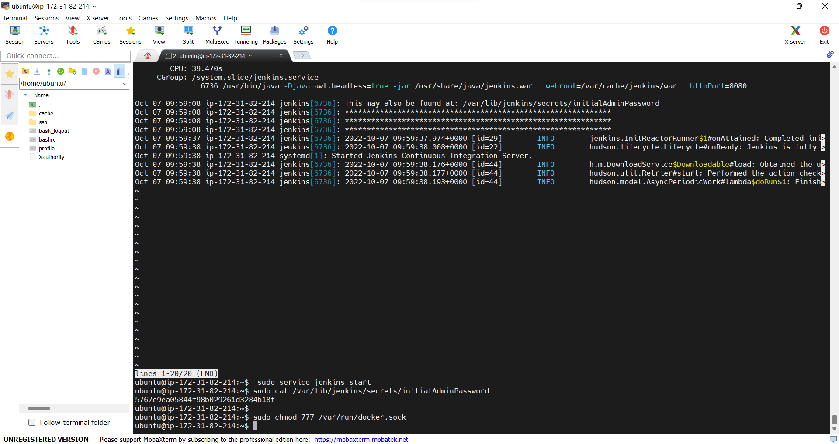

**Build Successful:**

